**PP2**

**Mathematics**

1. Count and select the correct number.

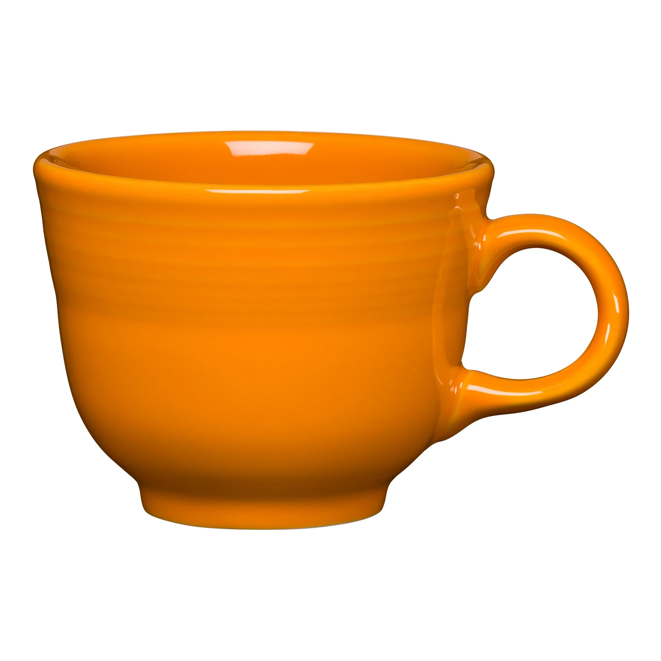 1, 3, 2

 5,4,6

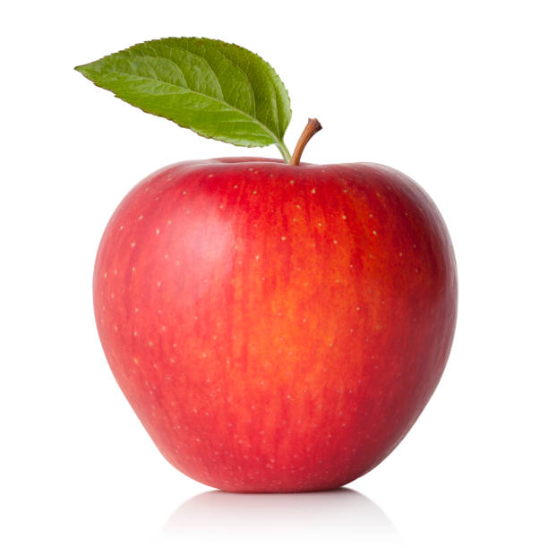 2,3,4

1. Fill in the missing numbers.

| **1** |  |  | **4** |  |  |
| --- | --- | --- | --- | --- | --- |

1. Add

 + =

+ =

4+1=

6+2=

1. Color the bigger object.

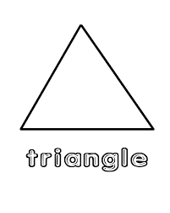

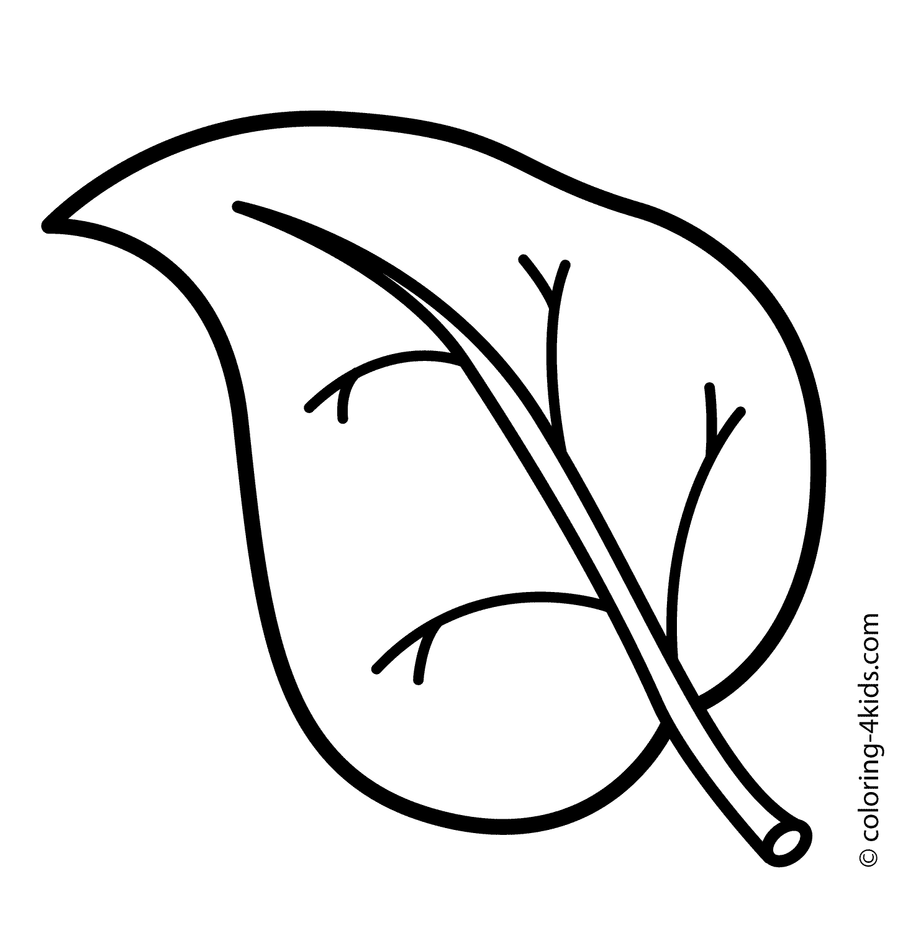 

**Language**

1. Color the word.

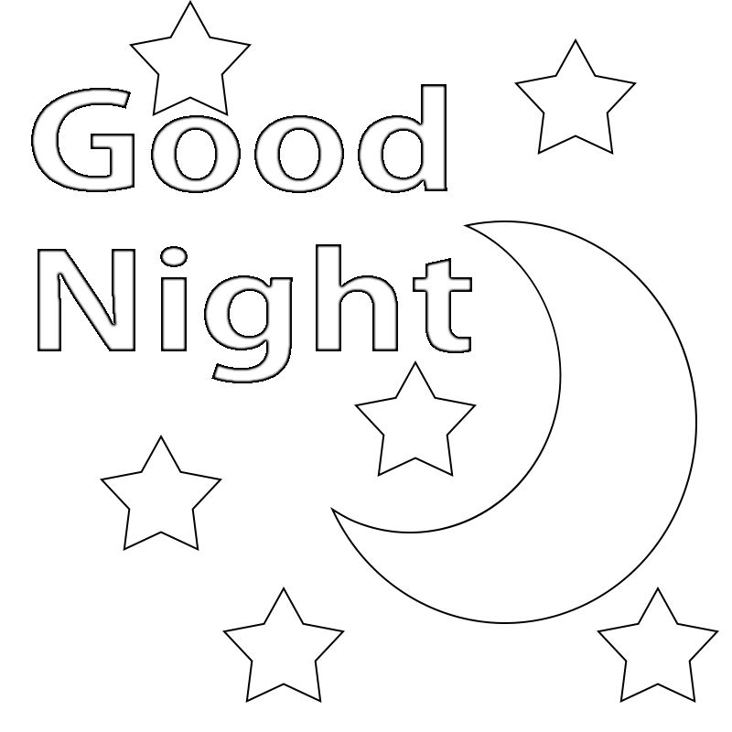

1. Write in capital letters

a A b……… c………… d…… e……….. F…………

1. Fill in with sound “a”

h_t

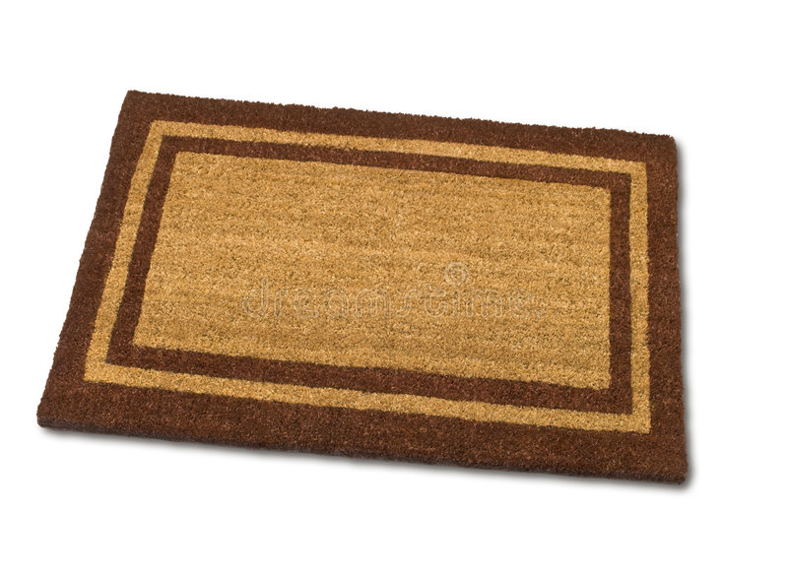m_t

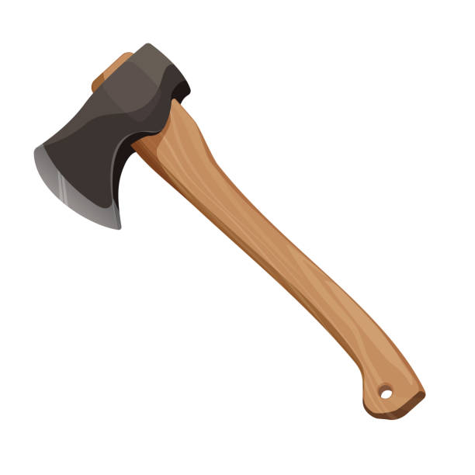_xe

1. Read and match

Cat Ten

Hen Dad

Bag Cat

Ten Hen

Dad Bag

**Reading**

1. Read these pictures.

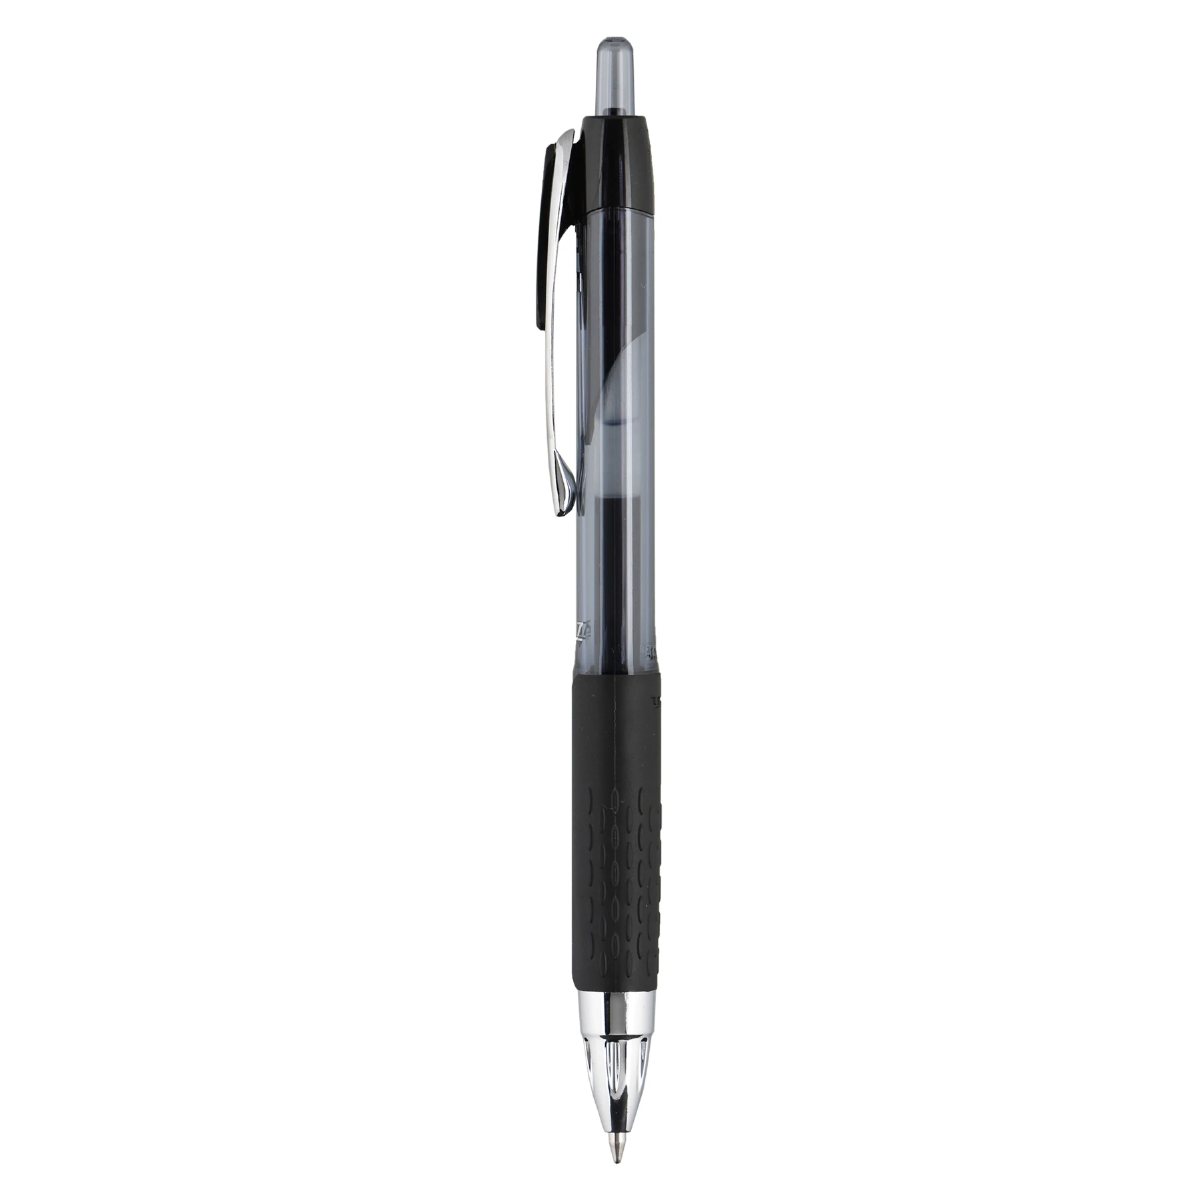 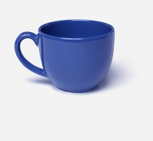 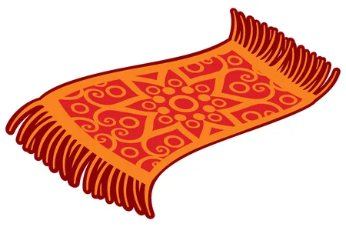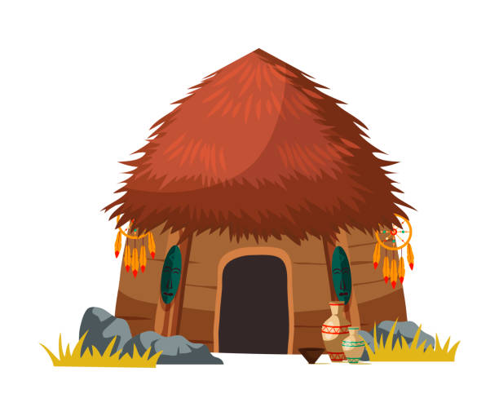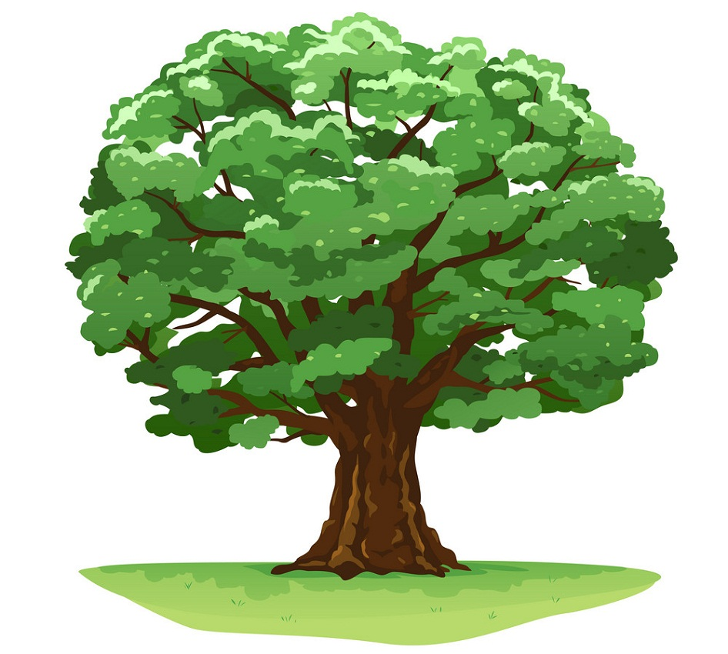

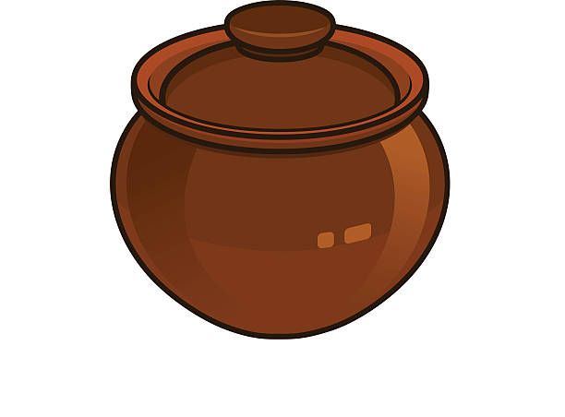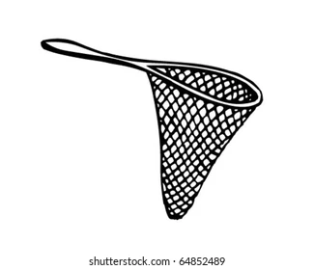

1. Read these words.

Boy Cup Pot It Fish Egg

Bell Hot Cat Apple Den Has

Is On Ball Pin Arm Leg

Of Doll Girl Dog Pet Tin

**Psychomotor and Creative Activities**

1. Color the picture

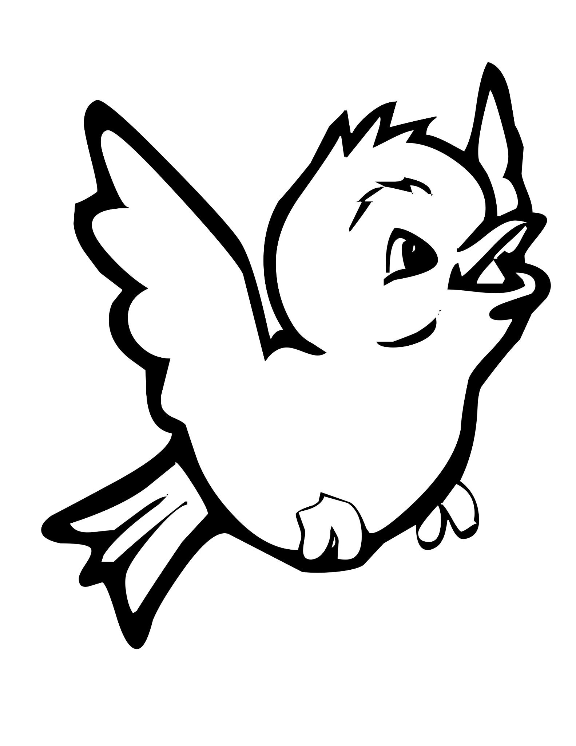

1. Complete the patterns.

C C C C C…………………………………………………..

S S S S S…………………………………………………

1. Color the traffic lights

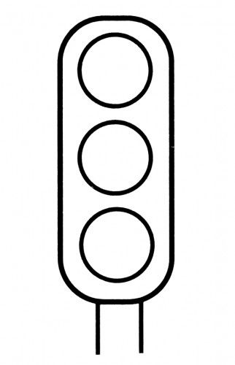

1. Color the slide.

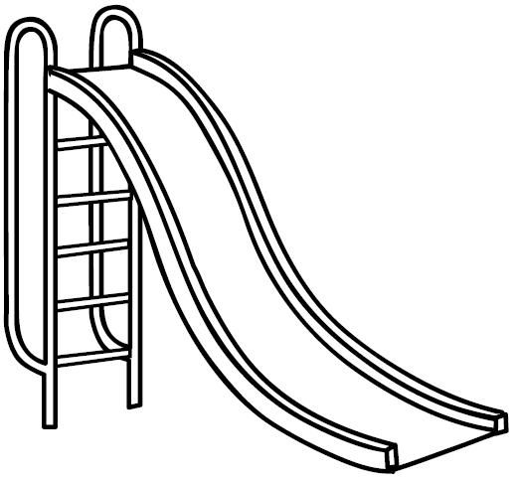

**Religious Activities**

1. Name 3 members of the family.
2. Match the body parts and it’s use.

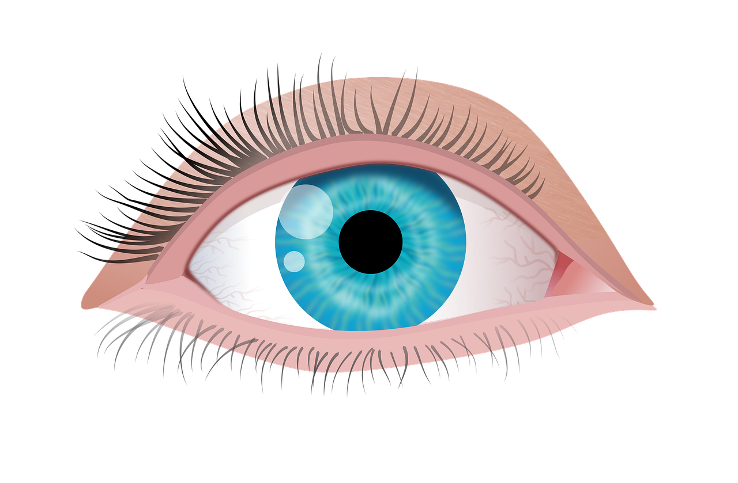 Work

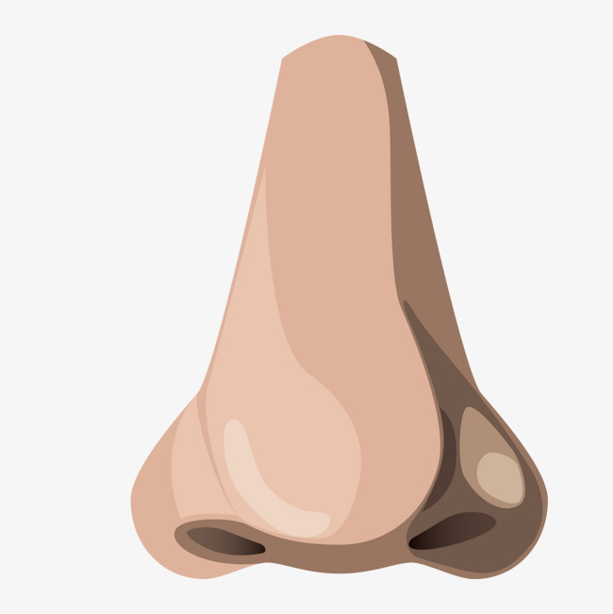 See

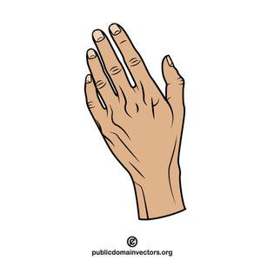 Smell

1. Draw and color God’s creations.

Bird

Fish

Tree

Mountain

1. We speak to God through………… (Phone, prayers)

**Environmental Activities**

1. Color these personal items.

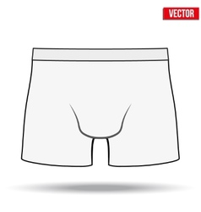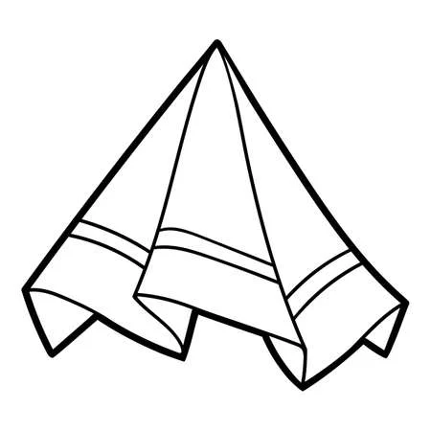

1. Name the source of water.

 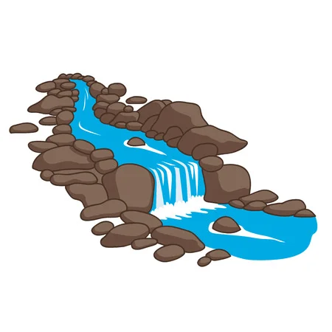

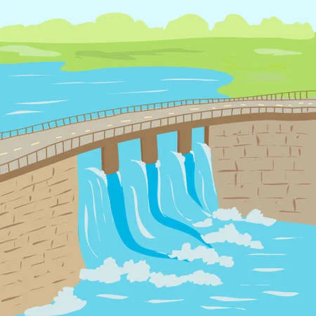 (Dam, Rain, Sea, River)

1. Name and color parts of the plant.

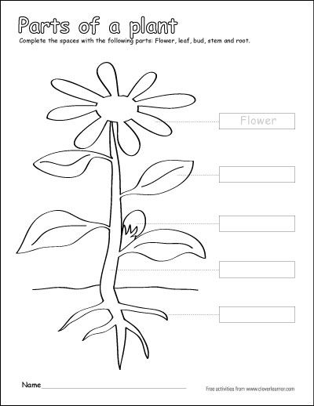(Flower, Stem, Leaf, Fruit, Roots)

1. A snake has……..legs (1,0,4)